Gender Impact Assessment Template

TPG23-27

1 October 2024

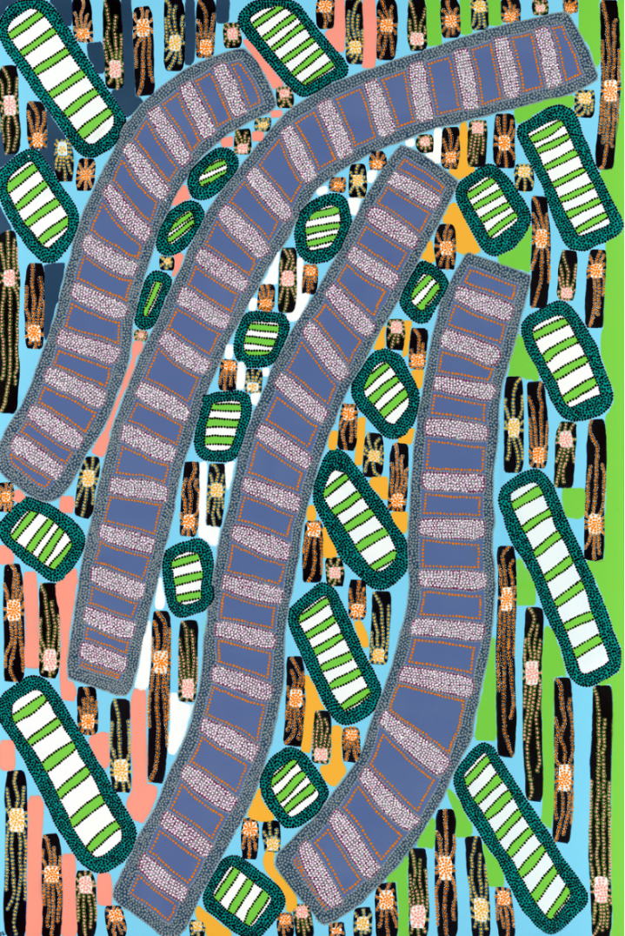

Acknowledgement of Country

We acknowledge that Aboriginal and Torres Strait Islander peoples are the First Peoples and Traditional Custodians of Australia, and the oldest continuing culture in human history.

We pay respect to Elders past and present and commit to respecting the lands we walk on, and the communities we walk with.

We celebrate the deep and enduring connection of Aboriginal and Torres Strait Islander peoples   
to Country and acknowledge their continuing custodianship of the land, seas and sky.

We acknowledge the ongoing stewardship of Aboriginal and Torres Strait Islander peoples, and the important contribution they make to our communities and economies.

We reflect on the continuing impact of government policies and practices, and recognise our responsibility to work together with and for Aboriginal and Torres Strait Islander peoples, families and communities, towards improved economic, social and cultural outcomes.

Artwork:   
*Regeneration* by Josie Rose

Gender Impact Assessment Template

|  |
| --- |
| Instructions   * Complete questions 1 to 6 and the summary at the end. * Provide links to any sources or data you are referencing, * Consider intersectional perspectives in your responses. If you are completing a First Nations impact assessment which contains relevant analysis on First Nations women, you can refer to the First Nations impact assessment in this document to avoid duplication. * Include findings in the business case, including in the distributional analysis (if applicable). * Submit the completed gender impact assessment to your Treasury Relationship Lead as an attachment to the New Policy Proposal. |

|  |  |
| --- | --- |
| Portfolio / Agency |  |
| Proposal Name |  |
| Contact | *Name, position, email, and phone* |
| Short description of the proposal | *(max. 100 words)* |
| Amount being sought | *Provide the estimated total cost for capital expenditure and cost over the budget and forward estimates for recurrent expenditure.* |

Analysing the gendered impact of the proposal

1. How does **the issue** you are seeking to address affect women, men or gender diverse people differently?

* *Tip: This question is about the problem you are trying to solve. Consider if some groups are disproportionately affected by the issue you are seeking to address, or if people have different needs due to their gender (including intersectional characteristics as appropriate).*

|  |
| --- |
|  |

1. What are the expected positive impacts of **the proposal** on women, men or gender diverse people?

* *Tip: Consider the design of the proposal and how it may benefit people differently due to their gender. Think about the positive impacts along the following themes:*

***Economic opportunity and advancement:*** *Will it increase economic security of women, men or gender diverse people by promoting equal access to employment and career advancement? Consider if it will reduce the gender pay gap,* *engage businesses that demonstrate gender equality in their workplace, promote workforce inclusivity, or improve access to paid parental leave and flexible work arrangements for men.*

***Health and wellbeing:*** *Will it support quality of life, safety, and the mental and physical health needs of women, men and gender diverse people? Consider if it will promote safe relationships and communities, raise awareness and understanding of the specific health needs of women/girls, men/boys and gender diverse people, provide tailored physical and mental health support, or offer housing solutions and homelessness prevention strategies.*

***Participation and empowerment:*** *Will it challenge gender roles, stereotypes and biases? For example, does it support women, men or gender diverse people to enter jobs or industries that they previously could not access, or challenge gender norms around unpaid care? Will it involve or support businesses that demonstrate gender equality outcomes? Will it promote the political, economic or social participation or leadership of underrepresented groups? Consider if it will support women, girls and gender diverse people to take up and continue to participate in public spaces, community life and sport.*

|  |  |  |  |  |  |  |  |  |
| --- | --- | --- | --- | --- | --- | --- | --- | --- |
| Please use the table below or provide your response in free text, using sources or data to support your response where possible.   |  |  | | --- | --- | | Theme | Positive impacts | | Choose an item. |  | | Choose an item. |  | | Choose an item. |  | |

1. How will you mitigate any risks, barriers or limitations of **the proposal** on women, men or gender diverse people?

* *Tip: Consider potential risks associated with the proposal on people of different genders, including barriers to access. What changes can you make to the design or implementation of the proposal to mitigate these impacts?*
* *Consider opportunities in leadership and decision making, organisational policies such as Gender Equality Action Plans, procurement strategies, and stakeholder engagement and consultation which could improve the proposal.*

|  |  |  |  |  |  |  |  |  |
| --- | --- | --- | --- | --- | --- | --- | --- | --- |
| Please use the table below or provide your response in free text.   |  |  | | --- | --- | | Risks, barriers or limitations | Mitigating strategies | |  |  | |  |  | |  |  | |

1. Does **the proposal** support any gender equality indicators? (Select the most relevant indicator, with a maximum of two indicators)

|  |
| --- |
| **Economic opportunity and advancement**  Increases women’s labour force participation in NSW  Decreases the underemployment rate for women in NSW  Increases the number of women business owners and entrepreneurs  Increases the skills and education levels of women and girls  Promotes economic security of women and/or gender diverse people  **Health and wellbeing**  Improves access to health care  Increases safe and stable housing in NSW  Supports reduction of gender-based violence, including domestic and family violence  **Participation and empowerment**  Supports recovery and resilience after natural disasters  Promotes the sharing of unpaid care and responsibilities  Improves access to quality early childhood education and care  Increases diverse gender representation in under-represented industries and sectors  Increases diverse gender representation in decision making and leadership  Increases safety in workplaces and / or public spaces  Eliminates gender stereotypes and roles  **Other**  Not applicable  Other: [Provide proposed gender equality indicator] |

Building the evidence base

1. What are the knowledge gaps about the gendered impacts of this issue?

* *Tip: This question is about identifying any gaps in research or disaggregated data for the issue you are seeking to address. If possible, how could the proposal help address this knowledge gap?*

|  |
| --- |
|  |

1. How will you collect data to monitor and/or evaluate the gendered impacts of the proposal?

* *Tip: Treasury has a* [*NSW Evaluation Policy and Guidelines*](https://www.treasury.nsw.gov.au/finance-resource/evaluation-policy-and-guidelines)*, which sets out best practice advice for agencies and evaluators to consider when scheduling, planning and undertaking evaluations.*
* *Tip: Evaluations or progress updates on the gendered impacts of the proposal can be included in your Department’s Gender Equality Action Plan annual report.*

|  |
| --- |
| **Please select the actions you will undertake to monitor and/or evaluate the gendered impacts of the proposal and include in your evaluation plan (where applicable).**  Collect gender disaggregated data  Source case studies from participants of different genders  Develop gender-specific indicators (qualitative and / or quantitative)  Ensure diverse gender representation in consultations and analysis  ☐ Monitor gender equality performance of organisations engaged to supply goods or services  Source gender expertise in the evaluation team  Ensure interim evaluation reports identify and respond to unintended gendered outcomes  Incorporate gender analysis in presentation of findings and recommendations  Other: [Provide short description below] |

|  |
| --- |
| Summary of the gender impact assessment (max 200 words)  In your response, please address the following questions:   * Will the proposal likely have a positive, neutral or adverse impact on gender equality? * What changes have been made to the proposal as a result of the gender impact assessment? * How will any gendered outcomes of the proposal be monitored? |

Glossary of terms

**Gender / gender identity:** One’s sense of whether one is a man, woman, non-binary, agender, genderqueer, genderfluid, or a combination of one or more of these definitions.[1]

**Gendered impact:** Consequences that are different, positively or negatively, for affected groups of women, men or gender diverse people.

**Gender norms:** A subset of social norms that relate specifically to gender differences. They are informal, deeply entrenched and widely held beliefs about gender roles, power relations, standards or expectations that govern human behaviours and practices in a particular social context and at a particular time.

**General government sector:** The general government sector represents the scope of the NSW Budget. Agencies in this sector generally operate under the Financial Management Framework and carry out policy, regulatory and service delivery functions. Refer to the Classification of Agencies.

**Intersectionality:** An approach that recognises that people’s lives are shaped by their identities, relationships and social factors to create intersecting forms of privilege and marginalisation.[2]

**New Policy Proposal (NPP):** A decision by Government that involves a new initiative or discretionary change to existing policy. Refer to [TPG21-11](https://arp.nsw.gov.au/tpg21-11-parameter-and-technical-adjustments-and-new-policy-proposals-measures/)[Parameter and Technical Adjustments and New Policy Proposals (Measures)](https://arp.nsw.gov.au/tpg21-11-parameter-and-technical-adjustments-and-new-policy-proposals-measures/)*[.](https://arp.nsw.gov.au/tpg21-11-parameter-and-technical-adjustments-and-new-policy-proposals-measures/)*

**Transgender and gender diverse:** These are inclusive umbrella terms that describe people whose gender is different to what was presumed for them at birth.[3]

52 Martin Place

Sydney NSW 2000

GPO Box 5469

Sydney NSW 2001

W: treasury.nsw.gov.au

1. NSW Health 2022, *NSW LGBTIQ+ Health Strategy 2022-2027.*
2. UN Women 2022, [Intersectionality Resource Guide and Toolkit: An Intersectional Approach to Leave No One Behind](https://unwomen.org.au/publications-and-resources/intersectionality-resource-guide-and-toolkit/).
3. NSW Health 2022, *NSW LGBTIQ+ Health Strategy 2022-2027.*